**Solutions**

Escenic provides the tools you need to deliver world-class web sites and online publications.

* **High traffic, high volume.**Escenic Content Engine is the motor driving some of the world's busiest online media operations.
* **Scalability.** Entry-level systems provide smaller organizations with exactly the same functionality and flexibility as Escenic's largest customers, and can easily be expanded to meet increasing demand.
* **Efficient workflows.** Escenic's Content Studio provides a multi-user editing environment designed to meet the demanding requirements of 24/7 online media operations.
* **Cross-platform.**Windows or Mac? Content Studio fits equally well into both worlds.
* **Open.** The Escenic platform is based on open, standard technologies such as Java, Javascript, SQL, HTTP/REST, HTML5, CSS, XML.
* **Flexible.** A combination of highly configurable widgets, REST APIs, JSP, tag libraries, XML-based content modelling, Java and Javascript APIs plus extensive documentation ensures that Escenic applications can be modified to meet almost any requirements.
* **Ready to go.** Despite its extreme flexibility, a preconfigured widget set offering standard functionality ensures that an Escenic system can be up and running with a minimum of development work.
* **Responsive design.** Escenic web site content adapts to the display context, ensuring that it looks good and performs well on any output device.
* **Multi-site.** One Escenic installation can drive all your web sites, with easy cross-publishing and content sharing between sites.

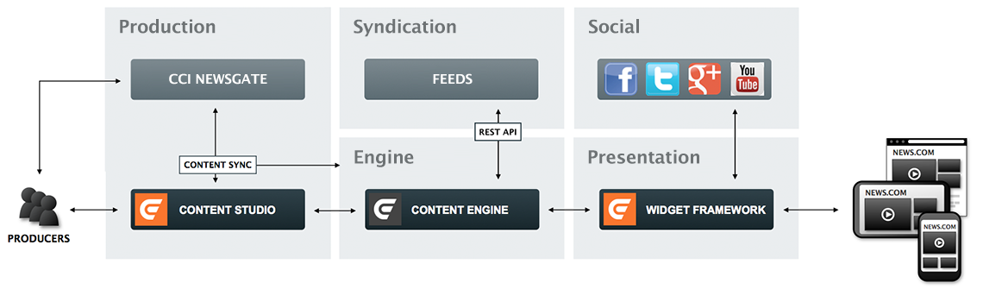

**Escenic Live Center**

#### **Integrated with your CMS**

As an Escenic plug-in, Live Center is a fully-integrated component of the Escenic content management system – a CMS specifically designed for newsrooms. That means live blogs are first-class citizens in Escenic publications, completely under your control – not embedded islands from a third-party software vendor's site. All the access rights and controls that apply to ordinary news content also apply to blog content – with no additional work required.

#### **Re-use existing content**

Full integration also means that including existing content from your CMS in live blog entries is really easy – pictures, text and videos can just be dragged into a live blog from Content Studio, the Escenic CMS client.

#### **Let freelancers contribute**

At the same time, it’s still easy to let a freelancer or blogger write a live blog for you – all you need to do is create an Escenic user account. The blogger can then just log in using his Facebook or Google credentials, and start writing.

#### **Monitor and include social media**

Adding content from social media and Youtube is just a drag-and-drop affair. Configurable social media feeds let you monitor relevant activity on all the important social media platforms, and simply drag tweets, videos or images directly into your blogs.

#### **Use any device, anywhere**

Live Center is browser-based and optimized for touch, so it can run on any device, and be used anywhere there's a network connection. It offers journalists and bloggers an intuitive, streamlined interface for instant productivity.

#### **Work fast, think big**

Live Center is designed from the ground up for speed and scalability. It offers true real-time reporting, with sub-second update times for as many simultaneous subscribers as you want.

#### **Technical description**

Live Center is a standard Escenic plug-in that extends the Escenic Content Engine with support for liveblogging.

A live blog (called an **event** in Live Center) is a sequence or feed of **entries** describing some news event as it unfolds. Each entry is generally brief and contains an update or comment on the unfolding situation. An entry can contain text, images, audio or video and can also hold embedded content from other web sources such as social media sites (Twitter, YouTube, Instagram and so on).

The entries in an event are usually listed in reverse-chronological order (that is, latest first), and new entries are **pushed** to readers: whenever a blog is updated by newsroom staff, all browsers displaying that page will be automatically updated to reflect the change.

Live Center entries are rather like standard Escenic content items: they can consist of many different fields of different types, and customers can configure their own entry-types to support different types of live blogs. But entries aren't in fact content items: they have a much simpler internal structure, optimized for speed.

The Live Center plug-in adds the following components to an Escenic installation:

* A special content type for holding events. Each event is a separate content item, created in Content Studio in the usual way.
* A new publication resource called **event-type**. The event-type resource holds entry structure definitions for different types of events, allowing customers to define their own event types.
* Additional Content Engine database tables for holding entry contents.
* The Live Center webapp: a modern, browser-based, mobile-friendly app written using modern client-side technologies such as Javascript and Angular. It enables:
  + in-house journalists and external bloggers to contribute to events
  + editors to review and control the publishing of entries
* An editorial web service. This read/write REST web service is the API through which the Live Center webapp communicates with the Escenic Content Engine. It can, however, also be accessed by customers' own applications and extensions if required.
* A presentation web service. This read-only REST web service exposes all published event content as JSON data. This technology-agnostic approach leaves site designers and developers free to implement their live blogging presentation layer using whatever languages and technologies they choose.
* Editorial and presentation change logs: web service endpoints that provide an efficient mechanism for following changes to events. Editorial and presentation layer code provides "push" functionality by polling these endpoints.

Escenic Content Studio

Content Studio offers a highly productive, streamlined editing environment for on-line content. Based on zero-install Java technology, Content Studio can be used on both Windows and Mac.

Content Studio is a client application that communicates with the [Escenic Content Engine](http://www.escenic.com/solutions/297/Escenic_Content_Engine) via a robust, fault-tolerant REST API. Together with the Content Engine It provides not just editing capabilities, but a complete collaborative production environment that encompasses content creation, editing, and publishing. It has:

* A flexible user access and permissions system that can easily be adapted to suit most corporate structures, and makes use of existing ActiveDirectory log-ins.
* An unobtrusive field-level locking mechanism for preventing editing conflicts in busy multi-user environments.
* A simple but effective set of workflow controls refined over many years to simplify the management of highly dynamic sites.
* Multi-device preview functionality that lets you see what your pages will look like on a range of different devices.

The Notes plug-in makes Content Studio an even better collaboration tool by allowing users to attach notes to content items and notify other users of changes. This enables discussions about the content and progress of a content item to follow it through the editorial process and be visible to all the editorial staff involved.

Content Studio offers a complete editorial solution for modern multimedia web sites. With the Video plug-in installed, Content Studio can handle not only text and image content, but also video and sound. The Video plug-in enables tight integration with a media asset management system such as[Vizrt](http://www.vizrt.com/)’s Viz One, from which Content Studio users can select, edit and publish audio and video content. A built-in timeline editor enables users to crop the selected video and audio clips and add cue points, graphics, events and annotations to them. The plug-in also hides all the complexities of transcoding video and audio content for multiple devices, enabling editorial users to simply publish and forget.

Escenic Cloud

The Escenic platform is now also available as a hosted cloud service. By choosing the Escenic Cloud you avoid up-front licensing costs, hardware costs, installation, configuration and maintenance. Instead you get access to a pre-installed and configured, fully operational Escenic system and web-hosting service from day one, for an agreed monthly rental fee.

Its key benefits include:

* Stability & peak-traffic security
* Reduced training requirements
* Lower cost
* Lower time-to-market
* Easy upgrades
* Security
* Scalability
* Agile development
* Controlled change management

The Escenic Cloud includes all the main Escenic system components:

* [Escenic Content Engine](http://www.escenic.com/solutions/297/Escenic_Content_Engine) with the standard set of plug-ins
* An agreed number of [Escenic Content Studio](http://www.escenic.com/solutions/298/Escenic_Content_Studio) seats
* The [Widget Framework](http://www.escenic.com/solutions/299/Widget_Framework)
* A working demo site

In addition, however, the Escenic Cloud also incorporates a fully-configured ready-to-use development environment based on best practices derived from Escenic’s many years of in-house development experience. This environment supports a simple, agile development workflow and encourages collaboration across professional boundaries. It is based on a combination of popular open source components and [Atlassian](https://www.atlassian.com/)’s world-beating development and collaboration tools:

* [GIT](http://git-scm.com/) for source code management
* [Maven](http://maven.apache.org/) for build/assembly
* [JIRA](https://www.atlassian.com/software/jira) for issue tracking and project management
* [HipChat](https://www.hipchat.com/) for communication and collaboration

The service is provided from virtual machines hosted in the Amazon cloud, and is therefore able to offer:

* Very high uptime
* World-wide accessibility
* On-demand scalability
* Extreme flexibility for dealing with peak demand

Escenic Content Engine

Based on JEE and SQL technology, the Escenic Content Engine provides a fast, reliable, extremely scalable and fully configurable repository for all your online content. It provides a flexible data model based on content types. Every content item (text articles, images, videos, sound clips and so on) is based on a user-defined content type that determines its structure. As well as providing the storage for all website content, the content engine also incorporates:

* A presentation layer for managing delivery of content to multiple channels
* An HTTP/REST API for communication with Escenic Content Studio and integration with other back-end and external systems
* A syndication subsystem for managing import from/export to other systems
* A highly efficient workflow for managing and publishing video/audio content
* Geotagging support
* Fast, flexible Solr-based search functionality both for public website search and internal editorial searches in Content Studio
* Support for website polls and voting
* Website analytics
* Automated sitemap generation
* Navigation structure editing and maintenance
* Revision history support
* Notes and notifications as collaboration tools in Content Studio

Integrations with a number of external systems are available, and can extend the Content Engine’s capabilities even further:

* CCI Newsgate for cross-media publishing
* CXense or Saplo for automated tagging
* Vizrt for media asset management and video graphics

# Widget Framework

* The Widget Framework is a modular website design toolkit that reduces the complexity of designing and implementing Escenic websites. Instead of working directly with HTML, Java, JSP, XML, CSS and Javascript code, designers are able to construct their websites from a collection of building blocks called widgets.
* Widgets are self-contained, interoperable code packages that can simply be slotted together in a drag-and-drop, code-free assembly process using [Escenic Content Studio](http://www.escenic.com/solutions/298/Escenic_Content_Studio). Despite the simplicity of the assembly process, the widgets are skinnable and highly configurable. They can therefore be used to provide a very wide range of different website structures and layouts. Even complex functionalities such as search can be added to a site without resorting to code editing.
* The Widget Framework drastically reduces the time required for web site development, making the construction of ad hoc sites for events and other special purposes an affordable proposition.
* The Widget Framework is based on the latest web standards, and generates clean HTML 5. [Bootstrap](http://getbootstrap.com/)-based responsive design together with the use of “lazy loading” ensures that the sites both look good and perform well on the widest range of client devices.
* A standard set of widgets is supplied with the Widget Framework. The supplied widgets cover most common requirements, rendering coding completely unnecessary for many customers. You can however easily extend it with custom code if necessary, either by modifying standard widgets or creating new widgets of your own.

# Escenic Plug-ins

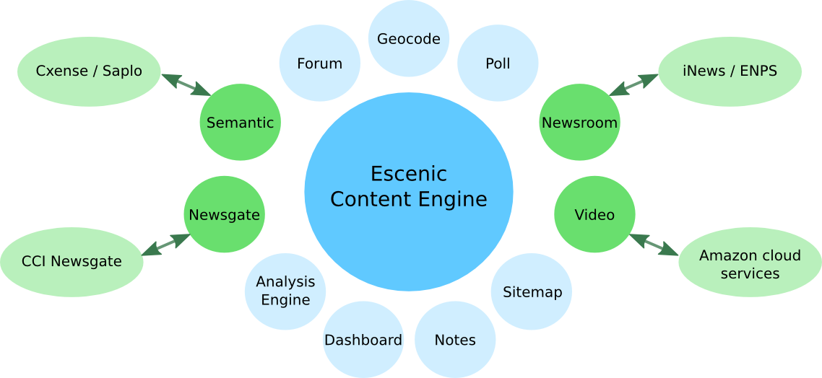

Escenic Content Engine has a modular architecture that ensures flexibility and extensibility. The Content Engine forms a stable kernel encapsulating all basic functionality, while more specialized functionality is provided by plug-ins. You only need to install the plug-ins you actually require, and you can enable and disable plug-ins on the fly from the Content Engine's system administration interface.

The plug-ins fall into two main categories:

* Standard plug-ins that are part of standard Escenic package
* Optional plug-ins that must be ordered separately. In general, optional plug-ins are those which provide integration with third-party systems

# Standard plug-ins

The standard plug-ins delivered with the Content engine are:

### **Analysis Engine**

Provides website statistics collection and analytics. The Analysis Engine can be set up to record a wide range of events and actions. This data can then be analyzed to generate reports on web activity, lists of popular articles for inclusion in publications and so on. The Analysis Engine includes an API for the creation of custom reports and integration with external systems.

The Analysis Engine can be used in combination with other tools such as [Google Analytics](http://www.google.com/analytics/), [Chartbeat](https://chartbeat.com/" \t "_blank), [cXense Analytics](http://www.cxense.com/solutions/analytics" \t "_blank), [Adobe Marketing Cloud](https://www.adobe.com/solutions/digital-marketing.html) and so on.

### **Dashboard**

Provides a web interface for moderating user-generated content, such as blog posts, article comments, pictures and videos and for managing user access rights, stop words, tags and so on.

### **Forum**

Provides a framework for adding forum management functionality to the Content Engine. The Forum plug-in supports a wide range of forum types and features:

* Independent discussion forums
* Article comments
* Both flat and threaded forums discussion structures
* Moderated and unmoderated forums (for moderated forums, the Dashboard plug-in is required as well)
* Pre-moderation (postings must be approved before publishing) and post-moderation (postings are published but can be withdrawn)
* Complaints
* Indexed/searchable forum content
* Pingback support

### **Geocode**

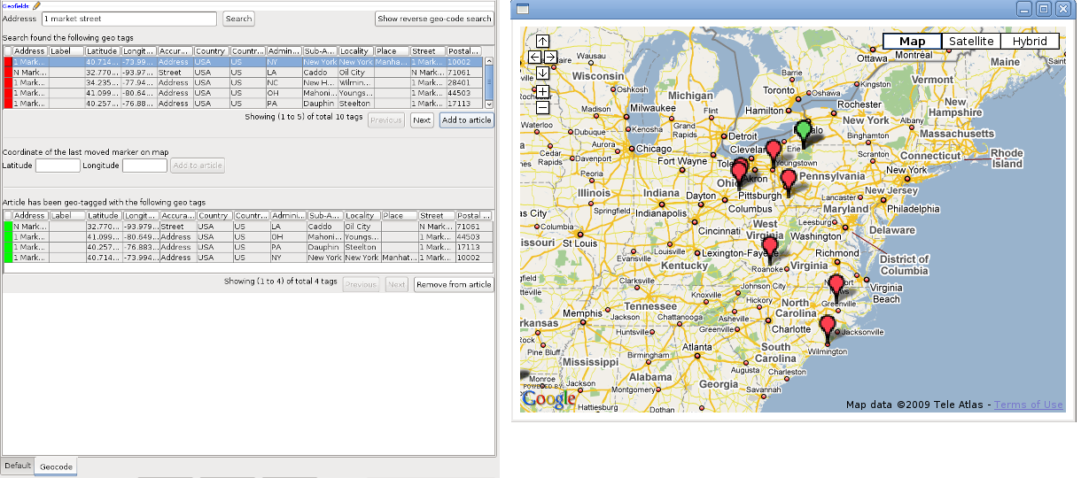

Adds easy-to-use geocoding functionality to Escenic Content Engine installations. It allows geographical location records (geotags) to be associated with content items.

With the Geocode plug-in, journalists and editors working in Content Studio are able to easily add geotags to a content item, which are then stored along with the content item in the Content Engine database. Once these tags are stored with content items, they can subsequently be used in a variety of ways:

* To search for items in Content Studio by location: either address (city, state, country) or coordinates
* To plot locations on maps
* To create user services that search for news by location

The Geocode plug-in requires access to a map provider such as [Google Maps](https://maps.google.com/) or an [OpenStreetMap](http://www.openstreetmap.org/" \t "_blank) provider, and has built-in support for both of these providers. You can add support for other map providers via an extension API if required.

### **Notes**

Enables notes discussions about a content item to follow it through the editorial process and be visible to the editorial staff working on the item. The plug-in

* Lets users add notes and comments to content
* Notifies users when notes have been added
* Displays notes alongside the content in Content Studio
* Stores notes with content items so that they form part of its editorial history

### **Poll**

Allows content creators to easily add polls (consisting of a question and a set of alternative answers) to Escenic publications.

### **Sitemap**

Generates sitemaps for Escenic sites. Sitemaps are XML files containing links to everything you want to be indexed by search engines. They provide an efficient means of directing search engines to the important content on your site.

If required, the Sitemap plug-in can be configured to include Google News and Google Video extension elements in sitemaps.

## **Additional plug-ins**

The following additional plug-ins are also available:

### **The Semantic plug-ins**

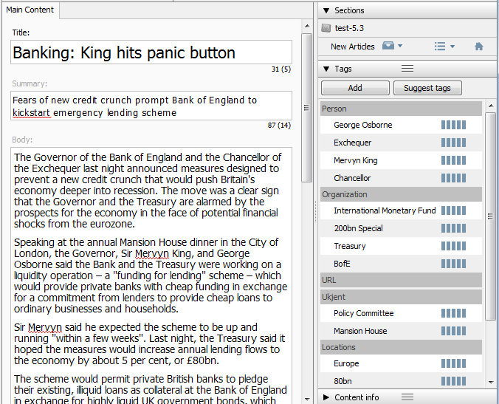

There are two semantic plug-ins that provide interfaces to two different tagging services: [cXense](http://www.cxense.com/" \t "_blank) and [Saplo](http://saplo.com/technologies" \t "_blank).

Tagging services search submitted content for references to various subjects and return tags associated with the subject references they find. The tags returned by both cXense and Saplo are weighted for relevance.

Both of the semantic plug-ins enable the Content Engine to:

* Submit content items to Saplo for analysis and tagging
* Map the returned Saplo tags to corresponding Escenic tags if they exist, or else create new tags
* Convert Saplo tag relevance weightings to Escenic tag relevance values

The Saplo Semantic plug-in also submits changes made to the tags back to Saplo. Saplo uses this feedback to customize its behavior, allowing you to improve the quality of the tagging over time.

### **Newsgate**

Enables two-way integration between Content Studio and [CCI Newsgate](http://www.ccieurope.com/Insight/CCI-NewsGate.aspx). It allows:

* Content Studio to be launched from CCI Newsgate
* A story created in CCI Newsgate to be opened in Escenic Content Studio.
* Changes made in Content Studio to be copied back to CCI Newsgate (including changes to a content item's related images, media and content items)
* Web previews of Newsgate story folders
* Exchange of content and meta data between Escenic Content Engine and CCI

[More](http://docs.escenic.com/newsgate.html)

## **Newsroom**

Provides an interface to the newsroom component of a [Vizrt](http://www.vizrt.com/" \t "_blank) broadcast system. The plug-in supports both [iNEWS](http://www.avid.com/US/products/iNEWS" \t "_blank) and [ENPS](http://www.enps.com/) newsroom systems running as part of a Vizrt broadcast system. It allows news items created in the newsroom system to be automatically imported into the Content Engine. As stories are saved in the newsroom, they automatically appear as content items in associated Escenic publications along with all their associated text, video and graphic components.

The plug-in lets you predefine:

* Which stories are to be transferred to the Content Engine
* Which Escenic content types are to be used for newsroom stories
* Which publication(s) newsroom stories are to appear in
* Which section of a publication newsroom stories are to be added to
* Which status (draft, published, etc.) newsroom stories are to be assigned when they are transferred to the Content Engine
* Which inbox and which lists newsroom stories are to be added to

### **Video Plugin**

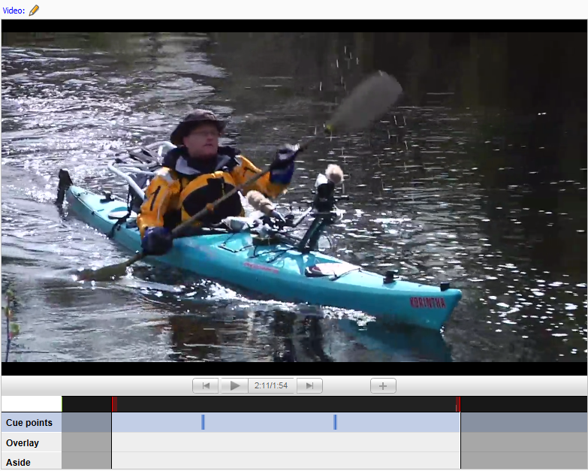

The Video plug-in extends Content Studio with the functionality required to efficiently manage web site media content. It offers:

* User-friendly video editing capabilities in Escenic Content Studio
* The ability to add “cue points” to a video, so viewers can jump directly to specific points
* Transcoding provided by Amazon Elastic Transcoder
* Optional distribution of published video items via Amazon Cloudfront (a high speed content delivery network)
* Advertising support - pre-, mid-, post-roll and overlay (depending on video player used)
* Cloud storage of video content in Amazon S3

The Video plug-in is intended to be used as a component of the Escenic Video Cloud - a managed service provided by Escenic that includes rental, configuration, operation and maintenance of all the Amazon services required to provide a turnkey video publishing solution.